AIR TICKETS APPLICATION FRAMEWORK
Created by Igor Evgrafov

Introduction
This document explains architecture and design guidance for AirTickets Framework. The main goal framework development is to simplify development process with possibility to be scalable.

Feature Specification

Requirements
The application framework should have following features:
- Perform authentication using 3rd party OAuth2 providers i.e. Google+.
- Perform seamless authentication.
- Build rich email (html with pdf attachment).
- Perform declarative resource authorization.
- Framework should allow system be installed in cloud environment.

Quality Risks
- It’s required to the client to work without freezes and to provide simple and clean user interface.
- Client should be modern and responsive; it should be easy to use, regardless of the device.
- Email alerts sent should be guaranteed (protected from temporary failures).

Constraints
- System must be single-page Application (SPA) application with responsive design.
- Both client and server should be built using modern java based tools.
- One of dependency management/build tools should be used (Maven, Gradle or SBT).
- Framework and working prototype to be developed and documented within 3 days.

Architecture and design

build tools
Maven is chosen as dependency management and build tool for the system.

Choosing Technologies for the Server
- Spring is chosen as main framework to build server. AirTickets Framework utilizes
  - Spring Web to build RESTful controllers
  - Spring Cloud to build RESTful client with service discovery and other cloud centric features (Feign).
  - Spring Data backed with Hibernate to provide RAD capabilities for database development.
  - Spring Security provides rich infrastructure for building authorization and authentication.
  - Spring Cloud Security additionally provides integration with 3rd party OAuth2 providers.

- Email templating is built on top Thymeleaf (XHTML part) and XDocReport to build PDF attachments.

Choosing technologies for client
- Main UI framework is AngularJS framework. It was chosen as well-known and leading framework for building SPA applications.
- Modern web UI should be running on devices with different screen resolutions and different input methods available. So we going to archive using Bootstrap framework.

Hight Level design
AirTickets application framework consists of two major modules:
- Core services module contains the application services that provides majority of the business logic rules, notification services and database access.
- UI module is responsible for UI itself and also it responsible for authorization and authentication.
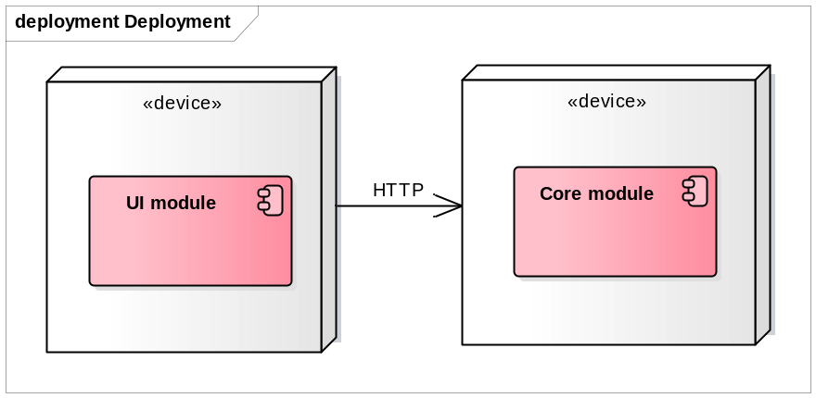

Architecture of the CORE MODULE
The server consists of the set of loosely coupled service:
- Notification services provide full infrastructure to build rich email notification with minimal effort.
- User service is responsible for managing User entity.
- Flight service is responsible for flight searching and management.
- Reservation service is responsible for ticket reservations, cancellation etc.

Level of coupling is decreased using publisher/subscriber approach for inter-service communications. All communications is synchronous in sake of simplicity, but system design allows transforming it to asynchronous/distributed model.

Architecture of the UI MODULE
UI module is Spring Boot + AngularJS application.
Server-side authentication and authorization is built using Spring Security / Spring Cloud Security.
Server-side security provides three types of authentication that seamlessly integrated in one system. There are:
- Extensible OAuth2 authentication system, it allows adding new provider simply by adding configuration properties. Current package consists of Google and Facebook integration. Only public users can use this authentication method.
- Second option for authenticating public users is simple access token authorization.
- Login / password based authentication is the only option to authenticate staff users.
Central part of UI module is RESTful controllers.

Deployment and Configuration
Deployment requirements:
- Minimal configuration: sensible defaults are applies to the majority of components. Only database and email server connections need to be configured to run the system.
- By default applications should be configured to work on the same machine. But it should be possible to use different machines for each system component.

